Logging in:

Use the link in “Welcome to Wix!” Click on the blue “Go to your site” button to enter the BC Garden Club website. The first time you enter the website, you will be prompted to set a password. Your username will be your email.

General Notes:

All contributors have access to all of the website. Please restrict your editing to your specific areas of responsibility.

CAUTION: If another contributor is working on the site, you will see a pop-up box similar to this one. Save your work immediately. Either come back another time or contact that individual to work out who needs to finish first.

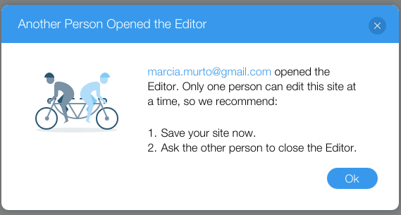

Your edits will not go live until you click on the blue “Publish” button in the upper right corner. You can work on your page(s) over time. However, if another contributor edits the website and publishes, your edits will go live.

Navigating & Tools:

The tool bar at the top has the following functions: Pages, Site, Tools, Help, Upgrade, Zoom, Undo, Redo, Mobile View, Save, Preview, Publish.

To go a specific page, click on the brown navigation bar at the top or the Pages link on the upper of the tool bar. A Pages menu will appear on the left. Then click on the specific page you want to edit.

Saving your edits:

The white “Save” button can be found on the tool bar on the upper right side of editor window. Click Save to confirm text changes or other edits on the page. You can see what the page looks like in Preview mode. Your changes do not become published until you click on the blue “Publish” button.

“HELP! I’ve done something I can’t fix!” Using the Undo function on the tool bar can fix mistakes. You can also just close the editor window and reply to the dialogue box when it reminds you that you have unsaved changes.

Editing your pages:

Editing the page can be done using the tool bar at the top to get to a specific page, then by clicking on a specific element on the page. Depending on the type of element (text, picture, etc), the appropriate tools will appear above the block.

Adding new items can be done by clicking on Add (+) button on the tool bar on the far left

Deleting items can be done by clicking on the item and hitting the Delete key on your key board, right clicking to bring up your mouse menu or your favorite “cut” key board shortcut.

Changing text:

Click on Edit Text button to make changes. A new dialogue box will open to the right.

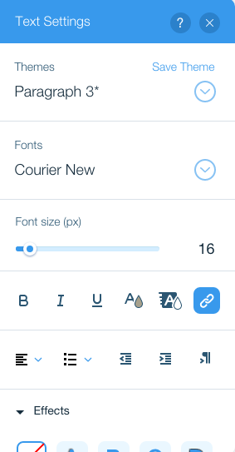

Adding a document

Type in your text, then highlight it. This dialogue box will open. Click on “document”.

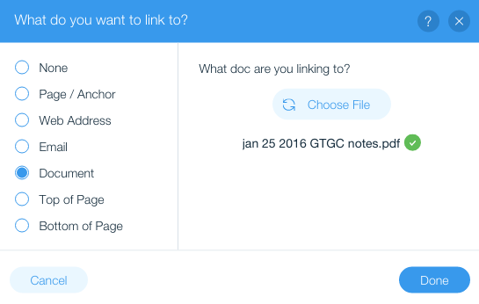

You will be prompted to upload your file to Wix, then select it

Adding a web link

Type in your text, then highlight it. This dialogue box will open. Click on “web address”. (Or page/anchor if the link is to another location in the BC Garden Club website)

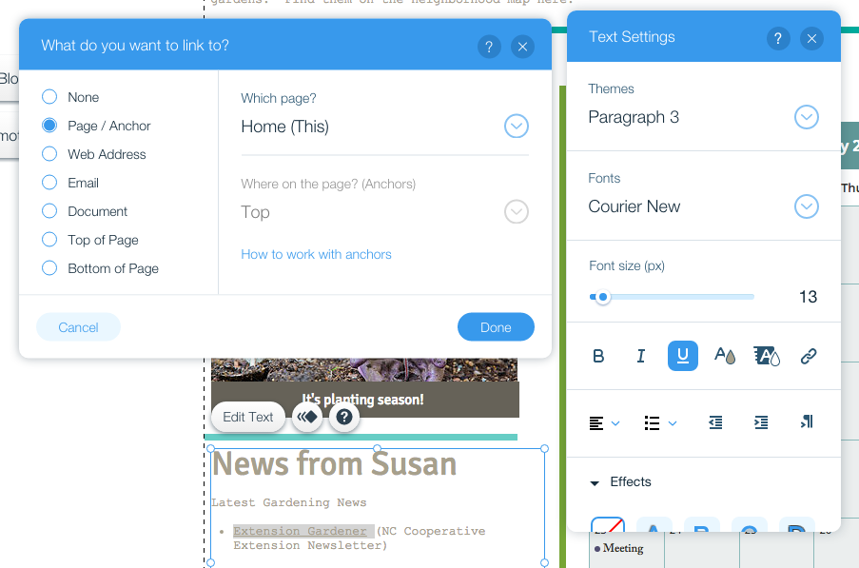

Adding a photograph

To add a photo (image), click on the + button on the left of the editor window. Click on image and then on your option (My image, Free Wix images, Free Wix clip art)

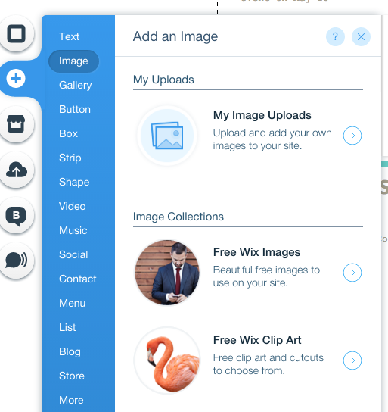

Note: Wix provides a library of free photos – free Wix images and Free Wix Clip Art. Feel free to use those or photos that were taken by members of the BC Garden Club. Using photos found on the web can lead to copyright/legal issues.

Run into problems or questions? Call Liz Rolison (919-270-0878) or Marcia Murto (919-271-0370)

